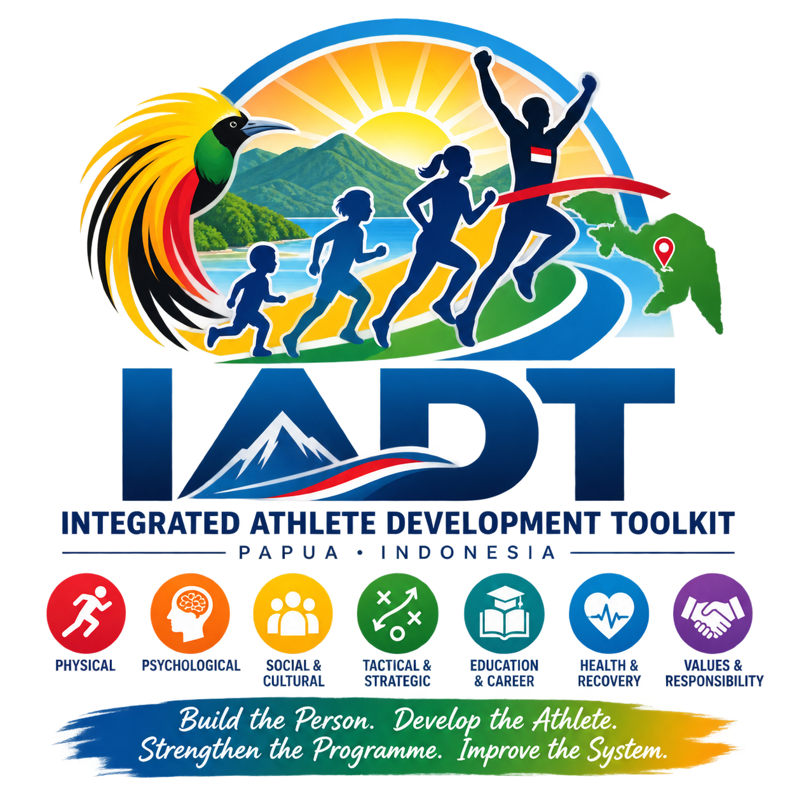
INTEGRATED ATHLETE DEVELOPMENT TOOLKIT
Master Framework and Rationalised Tool Index
Working Draft: Version 0.3
Date: 5 September 2026
Primary Demonstration Environment: Papua, Indonesia
Initial Pilot Location: Doyo Baru Sport and Recreation Complex
Related Systems: Integrated Sport Management Toolkit (ISMT) and Integrated Leadership Development Resources (ILDR)
Build the person. Develop the athlete. Strengthen the programme. Improve the system.

Document Control
Item | Details
Document title | Integrated Athlete Development Toolkit Master Framework and Rationalised Tool Index
Document code | IADT-MF-001
Version | Draft 0.3
Date | 5 September 2026
Status | Working revision — athlete-focused architecture and duplication reduction
Primary purpose | Guide the design, testing and implementation of tools that directly support the development of individual participants and athletes.
Primary testing environment | Papua, with initial testing at Doyo Baru
Related systems | ISMT — organisations and environment; ILDR — leadership knowledge, skills and competencies
Intended formats | Microsoft Excel and Word, with later digital integration after field testing

Executive Summary
The Integrated Athlete Development Toolkit (IADT) is the athlete-focused component of the wider Integrated Sport Management system. Its purpose is to help coaches, athletes and relevant support personnel understand the athlete, plan development, organise an appropriate individual programme, monitor progress and make better progression and transition decisions.
Draft 0.3 narrows the scope deliberately. Earlier versions allowed organisational capability, facilities, workforce, competition systems and other environmental factors to enter IADT as separate assessments. Those matters remain important to athlete development, but they belong primarily in the Integrated Sport Management Toolkit (ISMT). Leadership capability belongs in the Integrated Leadership Development Resources (ILDR). IADT may reference those factors when they materially affect an athlete, but it should not duplicate their assessment.
The practical consequence is a simpler architecture built around the athlete journey:
- Profile the athlete once and reuse the information.
- Determine current development stage and aspirations.
- Assess the athlete holistically across the eight development domains.
- Agree a small number of development priorities and actions.
- Build an athlete programme that integrates training, competition, recovery and life commitments.
- Review progress with the athlete and adapt the programme.
- Use specialist tools only when a real decision requires them, including progression, transition, competition suitability, growth / maturation, support needs and talent-identification safeguards.

1. Purpose and Scope of the IADT
The purpose of the IADT is:
To help each participant or athlete understand where they are now, where they want to go, what they need to develop, what programme should support them, whether they are progressing, and what should happen next.
The IADT therefore answers six athlete-centred questions:
- Who is this athlete and what is their current development context?
- What development stage and pathway options are appropriate for them?
- What are their strengths, needs, aspirations and support requirements?
- What individual development plan and programme should be delivered?
- Is the athlete progressing appropriately and experiencing sport positively?
- Is the athlete ready to progress, transition, continue, change direction or receive additional support?

2. Clear Boundaries Between IADT, ISMT and ILDR
The three tool families should complement each other without repeatedly assessing the same issue. The boundary is based on the primary subject being developed.
Tool Family | Primary Subject | What It Assesses / Develops | Examples
IADT | The participant or athlete | The athlete's profile, development stage, holistic needs, individual plan, programme, progress, competition suitability, transition and progression readiness. | Athlete Passport; Holistic Athlete Profile; Individual Development Plan; Athlete Programme Planner; Progress Review.
ISMT | The organisation and its environment | Governance, strategy, facilities, workforce, competitions, finance, systems, partnerships and environmental conditions that influence sport delivery. | Governance RAT; Facility tools; STR tools; organisational and pathway environment assessments.
ILDR | The leader | Knowledge, skills, competencies, role expectations, feedback and development of leaders at all levels. | Role profile; self-assessment; feedback; leadership development plan.
A practical boundary rule applies: if the question is primarily 'Is the organisation / system capable?', use ISMT. If the question is 'Is the leader capable?', use ILDR. If the question is 'What does this athlete need or are they ready?', use IADT.

3. Athlete-Centred Principles
- The person comes before performance. Health, dignity, safety and long-term interests are non-negotiable.
- Development matters more than early results.
- Developmental readiness matters more than chronological age alone.
- Different athletes may pursue recreational, competitive, talent, elite or lifelong-participation destinations.
- Movement through the pathway may be non-linear. Athletes may enter late, change sports, pause, return, progress quickly or remain at a preferred level.
- Physical literacy and broad development remain important foundations.
- Competition should serve development rather than dominate it.
- Coaching should be person-centred, strengths-based and responsive to athlete voice.
- Wellbeing, education, family, cultural identity and life commitments are part of athlete development.
- Only information that helps a development, welfare, progression or accountability decision should be collected.
- Sensitive medical or safeguarding information should not be duplicated unnecessarily inside general IADT workbooks.
- Specialist tools should be optional. The core athlete workflow should remain usable without completing every IADT tool.

4. Evidence and Reference Foundations
The conceptual foundations from Draft 0.2 remain appropriate. IADT uses them as reference lenses rather than rigid prescriptions.
Foundation | Contribution to Athlete-Focused IADT
Sport for Life / Long-Term Development | Progressive development, positive first experiences, physical literacy, appropriate competition and lifelong involvement.
UK athlete-development practice | Person-centred coaching, growth / maturation awareness and flexible athlete pathways.
Australian FTEM | Foundation, Talent, Elite and Mastery as a flexible whole-of-sport pathway reference, especially for athlete transitions and non-linear progression.
Australian Physical Literacy Framework | Physical, psychological, social and cognitive development across the life course.
Australian athlete wellbeing practice | Education / career balance, wellbeing, transition support, positive relationships and life development alongside performance.
Positive psychology / PERMA | Strengths, engagement, relationships, meaning and accomplishment integrated across existing athlete domains rather than creating another assessment layer.

5. Athlete Development Pathway
IADT continues to use Sport for Life developmental language and FTEM as complementary reference lenses. These references describe the athlete journey; they do not create an organisational assessment.
Sport for Life Reference | Primary Athlete Focus | FTEM Lens
Awareness / First Involvement | Positive entry, belonging, orientation and enjoyment. | Foundation
Active Start / FUNdamentals / Learn to Train | Movement competence, confidence, broad sport skills and learning habits. | Foundation
Train to Train | Progressive sport-specific development and consistent training habits. | Foundation / Talent
Train to Compete | Individualised development, appropriate competition and expanded support. | Talent / Elite
Train to Win | Sustained high-performance preparation with coordinated life and performance support. | Elite / Mastery
Active for Life | Continued participation, return to sport, leadership, coaching, officiating and contribution. | Across pathway
For practical implementation in Papua, the FTEM macro phases should continue to be preferred over all ten micro-phases unless a sport has a clear reason to use greater detail.

6. Eight Athlete Development Domains
Domain | Athlete Focus
Technical | Execution, consistency, movement quality, adaptability and sport-specific technique.
Tactical & Decision-Making | Understanding, observation, anticipation, problem-solving and decisions under pressure.
Physical | Movement competence, mobility, balance, coordination, speed, strength, power, endurance and sport-specific capacity.
Psychological | Confidence, concentration, motivation, emotional control, resilience, goal-setting and self-management.
Social & Cultural | Teamwork, communication, respect, leadership, cultural identity, belonging and relationships.
Lifestyle, Education & Career | School / study, employment, family responsibilities, time, transport, financial pressures and future planning.
Health, Recovery & Welfare | Health, injury status, nutrition, hydration, sleep, recovery, mental wellbeing, safeguarding and access to appropriate support.
Values & Personal Responsibility | Honesty, discipline, respect, responsibility, fairness, integrity, care for equipment / facilities and contribution to others.
Positive psychology remains integrated across these eight domains. It is not a ninth domain and should not create an additional form.

7. IADT Operating Cycle
Stage | Athlete-Centred Question | Typical IADT Output
Assess | What is the athlete's current position, strengths, needs and readiness? | Passport, stage assessment, holistic profile, specialist assessment.
Plan | What should the athlete work on and what support is required? | Individual Athlete Development Plan.
Deliver | What training, competition, recovery and life-balanced programme should be undertaken? | Athlete Programme Planner.
Monitor | What is actually happening and how is the athlete responding? | Attendance, progress evidence, athlete feedback, specialist monitoring.
Review | What has changed and what does the athlete say about the experience? | Athlete Progress & Coach Review.
Improve | What should continue, change, progress, pause or receive additional support? | Revised plan, progression decision, transition plan or referral.

8. Rationalised IADT Tool Architecture
The tool index has been reduced and reorganised to remove duplication. Tools retained in IADT must directly help understand, plan, deliver, monitor or make decisions about an athlete.
Code | Tool | Purpose | Use
IADT-01 | Athlete Development Passport | Single reusable master record of athlete identity, current sport context, pathway position, aspirations and key commitments. | Core
IADT-02 | Athlete Journey & Pathway Map | Shows the athlete's current position, realistic next options, possible transitions and preferred long-term involvement. | Core / as needed
IADT-03 | Development Stage Assessment | Helps determine the athlete's current development position using readiness, experience, competence and aspirations rather than age alone. | Core / placement
IADT-04 | Sport Development Requirements Matrix | Technical reference describing what an athlete generally needs at different stages of a specific sport. | Reference / specialist
IADT-06 | Holistic Athlete Profile | Assesses the individual athlete across the eight IADT domains, including strengths, wellbeing and support needs. | Core
IADT-07 | Individual Athlete Development Plan | Converts assessment findings into a small number of priorities, objectives, actions, responsibilities and review dates. | Core
IADT-08 | Growth & Development Monitoring Record | Optional simple record of growth, maturation, coordination and training response without medical diagnosis. | Specialist / optional
IADT-09 | Athlete Progress & Coach Review | Merged progress review and coach-athlete discussion covering evidence, athlete voice, wellbeing, programme quality and revised priorities. | Core
IADT-10 | Transition & Retention Plan | Supports the athlete through changes of group, coach, club, school, location or performance level and when at risk of leaving sport. | Specialist / as needed
IADT-11 | Athlete Programme Planner | Combines annual, phase and weekly programme planning in one workbook, balancing training, competition, recovery and life commitments. | Core
IADT-14 | Competition Appropriateness Assessment | Determines whether a proposed competition or competition schedule is appropriate for the individual athlete's development. | Specialist / as needed
IADT-16 | Athlete Progression Readiness Assessment | Determines whether the individual athlete is ready to progress to a new stage, group, competition level or performance demand. | Specialist / decision point
IADT-17 | Athlete Support Needs & Referral Record | Records individual support needs, agreed referrals and follow-up without assessing the whole support-service system. | Specialist / as needed
IADT-18 | Cohort Athlete Development Dashboard | Aggregates athlete-level information to show participation, retention, progress, transitions, wellbeing and related athlete outcomes. | Management output
IADT-19 | Talent Identification Safeguards | Checks athlete selection decisions for premature judgement, maturation / relative-age bias, unequal access and over-reliance on current performance. | Specialist / selection

9. Tools Merged, Transferred or Retired
Former Code / Tool | Decision | Reason / New Home
IADT-05 Athlete Development Environment Assessment | Transfer out of IADT | Environment, facilities, coaching structures, competition systems and organisational capability are ISMT matters. IADT may record how an environmental issue affects an athlete, but does not reassess the environment.
IADT-12 Training Phase Planner | Merge into IADT-11 | Annual, phase and weekly planning should sit in one Athlete Programme Planner rather than three separate workbooks.
IADT-13 Weekly Athlete Programme | Merge into IADT-11 | Reduces repeated planning and keeps annual-to-weekly programme logic together.
IADT-15 Coach–Athlete Review Tool | Merge into IADT-09 | Athlete progress review and coach-athlete discussion are one review process, not two.
Former IADT-16 Athlete Pathway Readiness Assessment | Replace function | Organisational pathway readiness belongs in ISMT. IADT-16 is redefined as Athlete Progression Readiness Assessment.
Former IADT-17 Athlete Support Services Matrix | Replace function | System availability of services belongs in ISMT. IADT-17 becomes the individual Athlete Support Needs & Referral Record.
IADT-20 Athlete Development Action Plan | Retire as standalone IADT tool | Individual athlete actions already belong in IADT-07, IADT-09 and IADT-16. Organisational / system actions belong in ISMT.

10. Core Athlete Workflow
The everyday IADT workflow should be short enough for a coach and athlete to use in practice:
Step | Tool | Purpose
1 | IADT-01 Athlete Development Passport | Enter reusable athlete context once.
2 | IADT-03 Development Stage Assessment | Confirm where the athlete currently sits when placement is not obvious.
3 | IADT-06 Holistic Athlete Profile | Understand the athlete across the eight development domains.
4 | IADT-07 Individual Athlete Development Plan | Agree a small number of development priorities.
5 | IADT-11 Athlete Programme Planner | Translate priorities into practical annual, phase and weekly delivery.
6 | IADT-09 Athlete Progress & Coach Review | Review evidence and athlete voice; adapt the plan / programme.
7 | IADT-16 Progression Readiness | Use only when a real progression decision is approaching.
IADT-02, 04, 08, 10, 14, 17 and 19 are optional or specialist. IADT-18 aggregates athlete-level information and should not require users to re-enter data.

11. Data, Automation and Usability Standards
- One fact, one home: reusable athlete information should be stored once and carried forward wherever practical.
- Minimum input first: tools should produce a useful result before optional detail is required.
- No organisational re-assessment inside IADT. Environmental blockers should be referenced and transferred to ISMT.
- No leadership competency assessment inside IADT. Leadership development belongs in ILDR.
- Use standard athlete identifiers, domains, stages, status labels and review dates.
- Automatically generate summaries, development priorities, progress indicators and printable outputs where this improves decisions.
- Do not automate clinical, safeguarding or professional judgements beyond the competence of the tool.
- Keep confidential medical and safeguarding records separate where appropriate; record only the status or referral information required for athlete development.
- All Excel releases must follow compatibility QA: no fragile dynamic arrays on operational sheets, no unnecessary merges, no hidden legacy objects, and reopen / formula-scan before release.

12. Papua Demonstration Model
Doyo Baru remains the preferred real-world testing environment, but the IADT pilot should test athlete tools rather than organisational capability. ISMT should be used in parallel to address the club, facility, programme environment, workforce and governance conditions surrounding the pilot.
Pilot Phase | IADT Focus | Related ISMT / ILDR Contribution
1. Athlete entry | Create IADT-01 passports and, where required, IADT-03 stage assessments. | ISMT confirms safe delivery environment; ILDR supports responsible leaders.
2. Athlete baseline | Complete IADT-06 for selected athletes. | ISMT addresses environmental gaps that limit athlete development.
3. Individual planning | Create IADT-07 plans and IADT-11 programmes. | ILDR / workforce development may support coaches and programme leaders where needed.
4. Delivery & review | Use IADT-09 and specialist monitoring tools. | ISMT tracks organisational delivery and resources.
5. Progression / transition | Use IADT-16, IADT-10, IADT-14 or IADT-19 where relevant. | ISMT manages opportunities, competition systems and external constraints.
6. Evaluation | Use IADT-18 to examine athlete outcomes and user practicality. | ISMT / ILDR evaluate organisational and leadership changes separately.

13. Monitoring and Evaluation
IADT success should now be judged primarily by athlete and coach use, not by whether the toolkit can assess every surrounding system condition.
- Athlete information is entered once and reused.
- Athletes can explain their goals and development priorities.
- Coaches can produce manageable individual plans and programmes.
- Athlete voice is visible in reviews and programme changes.
- Progression and competition decisions use evidence rather than age or current results alone.
- Wellbeing, education, family and cultural context are considered alongside performance.
- Specialist tools are used only when needed.
- Environmental blockers identified through athlete work are transferred to ISMT rather than duplicated.
- Leadership development needs are transferred to ILDR rather than built into athlete tools.
- Local coaches and administrators can operate the core athlete workflow with limited external assistance.

14. Revised Development Sequence
Priority | Tools | Development Decision
Immediate | IADT-01, IADT-06, IADT-07 | Establish the athlete record → holistic baseline → individual plan sequence.
Immediate / next | IADT-09, IADT-11 | Build the combined review process and consolidated Athlete Programme Planner.
Decision-point tools | IADT-03, IADT-14, IADT-16, IADT-19 | Develop / refine only when placement, competition, progression or selection decisions require them.
Specialist support | IADT-08, IADT-10, IADT-17 | Use selectively for growth / maturation, transition / retention and athlete support referrals.
Management output | IADT-18 | Build only after athlete-level data structures are stable enough to aggregate without repeated entry.
Reference | IADT-02, IADT-04 | Keep simple and visual / reference-oriented; avoid turning them into additional assessments.

15. Decisions Required During Field Testing
- How much athlete information can coaches realistically maintain without reducing coaching time?
- Which information should transfer automatically between IADT tools?
- Can IADT-01 and IADT-06 remain clearly distinct in practice: factual passport versus holistic assessment?
- Can IADT-11 genuinely replace three separate annual, phase and weekly programme tools?
- How often should IADT-09 reviews occur for community, competitive and performance athletes?
- What evidence is sufficient for IADT-16 progression decisions at different levels?
- Which specialist tools are actually used in field conditions and which can remain optional references?
- Which athlete-level dashboard indicators are genuinely useful to coaches, athletes and programme managers?

16. Expected Outputs
- Athlete Development Passport
- Athlete journey / pathway view
- Development-stage placement when required
- Holistic Athlete Profile
- Individual Athlete Development Plan
- Integrated Athlete Programme Planner
- Athlete Progress & Coach Review
- Growth / maturation monitoring where appropriate
- Competition suitability decision
- Transition / retention plan
- Athlete support / referral record
- Athlete progression readiness decision
- Talent-identification safeguard record
- Cohort athlete-development dashboard

17. Conclusion
The revised IADT is deliberately narrower and stronger. It does not attempt to manage the organisation, facility, workforce, competition system or leadership structure around the athlete. Those matters remain essential, but they are addressed through ISMT and ILDR.
IADT begins with the athlete and remains with the athlete: who they are, what they want, what they need, what programme will help them, what progress is occurring and what should happen next. This boundary reduces duplication and should make the toolkit more practical for coaches, athletes and local programmes.
The athlete is the subject of IADT. The organisation is the subject of ISMT. The leader is the subject of ILDR.

Reference Sources
Reference | Web address
Sport for Life — Long-Term Development | https://sportforlife.ca/long-term-development/
Sport for Life — Key Factors | https://sportforlife.ca/key-factors/
UK Coaching — Growth, Maturation and Development | https://www.ukcoaching.org/
UK Sport — Para Athlete Development Framework | https://stories.uksport.gov.uk/para-athlete-development-framework/
Australian Sports Commission — FTEM Pathways | https://www.ausport.gov.au/ais/ftem
Gulbin et al. (2013) — Integrated framework for optimisation of sport and athlete development | https://doi.org/10.1080/02640414.2013.781661
Australian Sports Commission — Australian Physical Literacy Framework | https://www.ausport.gov.au/physical_literacy
Australian Sports Commission — Win Well 2032+ Strategy | https://www.ausport.gov.au/winwell/strategy
AIS Athlete Wellbeing and Engagement principles | https://www.ausport.gov.au/ais
Hoare, Couston & Hall (2022) — Wellbeing science in adolescent high-performance athletes | https://doi.org/10.3389/fpsyg.2022.856241

