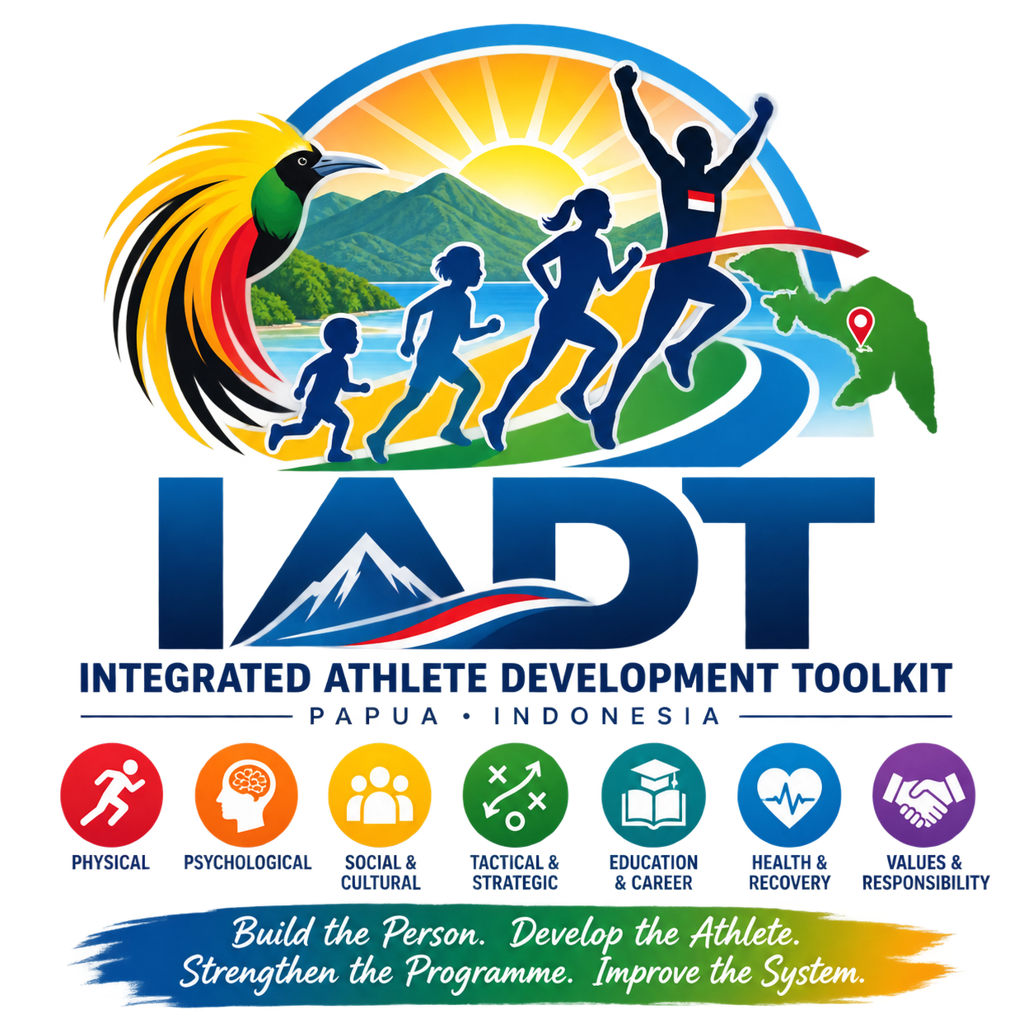
INTEGRATED ATHLETE DEVELOPMENT TOOLKIT
Master Framework — Athlete-Focused Summary
Working Draft: Version 0.3
Date: 5 September 2026
Primary Demonstration Environment: Papua, Indonesia
Initial Pilot Location: Doyo Baru Sport and Recreation Complex
Related Systems: Integrated Sport Management Toolkit (ISMT) and Integrated Leadership Development Resources (ILDR)
Build the person. Develop the athlete. Strengthen the programme. Improve the system.

1. What Changed in Draft 0.3
The IADT has been deliberately narrowed so that its tools are specifically about the participant or athlete. Organisations and environmental conditions are addressed through ISMT; leadership knowledge, skills and competencies are addressed through ILDR.
Tool Family | Primary Subject | Main Question
IADT | Athlete | What does this athlete need, what should they do next, and are they progressing appropriately?
ISMT | Organisation & environment | Is the organisation and its operating environment capable of supporting quality sport delivery?
ILDR | Leader | What knowledge, skills and competencies does this leader need to perform and develop?

2. The Athlete-Focused IADT Workflow
Step | Tool | Function
1 | IADT-01 Athlete Development Passport | Enter reusable athlete information once.
2 | IADT-03 Development Stage Assessment | Confirm development position when placement is uncertain.
3 | IADT-06 Holistic Athlete Profile | Assess the athlete across the eight domains.
4 | IADT-07 Individual Athlete Development Plan | Agree a small number of priorities and objectives.
5 | IADT-11 Athlete Programme Planner | Plan training, competition, recovery and life commitments.
6 | IADT-09 Athlete Progress & Coach Review | Review evidence and athlete voice; update the plan.
7 | IADT-16 Athlete Progression Readiness | Use when a real progression decision is approaching.

3. Eight Athlete Development Domains
Domain | Focus
Technical | Execution, consistency, movement quality, adaptability and sport-specific technique.
Tactical & Decision-Making | Understanding, observation, anticipation, problem-solving and decisions under pressure.
Physical | Movement competence, mobility, balance, coordination, speed, strength, power, endurance and sport-specific capacity.
Psychological | Confidence, concentration, motivation, emotional control, resilience, goal-setting and self-management.
Social & Cultural | Teamwork, communication, respect, leadership, cultural identity, belonging and relationships.
Lifestyle, Education & Career | School / study, employment, family responsibilities, time, transport, financial pressures and future planning.
Health, Recovery & Welfare | Health, injury status, nutrition, hydration, sleep, recovery, mental wellbeing, safeguarding and access to appropriate support.
Values & Personal Responsibility | Honesty, discipline, respect, responsibility, fairness, integrity, care for equipment / facilities and contribution to others.

4. Rationalised Tool Set
Code | Tool | Status
IADT-01 | Athlete Development Passport | Core — redesigned
IADT-02 | Athlete Journey & Pathway Map | Core / as needed
IADT-03 | Development Stage Assessment | Core / placement
IADT-04 | Sport Development Requirements Matrix | Reference / specialist
IADT-06 | Holistic Athlete Profile | Core
IADT-07 | Individual Athlete Development Plan | Core
IADT-08 | Growth & Development Monitoring Record | Optional specialist
IADT-09 | Athlete Progress & Coach Review | Core — absorbs former IADT-15
IADT-10 | Transition & Retention Plan | As needed
IADT-11 | Athlete Programme Planner | Core — absorbs former IADT-12 and IADT-13
IADT-14 | Competition Appropriateness Assessment | As needed
IADT-16 | Athlete Progression Readiness Assessment | Decision-point tool — redesigned
IADT-17 | Athlete Support Needs & Referral Record | As needed — redesigned
IADT-18 | Cohort Athlete Development Dashboard | Management output
IADT-19 | Talent Identification Safeguards | Selection safeguard

5. Removed Duplication
Former Tool | Decision
IADT-05 Environment Assessment | Move to ISMT. IADT records only how an environmental issue affects an athlete.
IADT-12 + IADT-13 | Merge into IADT-11 Athlete Programme Planner.
IADT-15 Coach–Athlete Review | Merge into IADT-09 Athlete Progress & Coach Review.
Former IADT-16 Pathway Readiness | Organisational readiness moves to ISMT; IADT-16 becomes athlete progression readiness.
Former IADT-17 Support Services Matrix | System availability moves to ISMT; IADT-17 becomes an individual athlete support / referral record.
IADT-20 Action Plan | Retire. Athlete actions already belong in IADT-07 / 09 / 16; system actions belong in ISMT.

6. Design Rules
- One fact, one home: do not repeatedly collect the same athlete information.
- Minimum input first; optional detail only where it improves a decision.
- Do not use IADT to reassess governance, facilities, workforce, finance or other organisational conditions.
- Do not use IADT to assess leadership competencies.
- Specialist tools remain optional.
- Environmental blockers can be referenced in IADT but should be transferred to ISMT for resolution.
- Leadership-development needs identified during athlete work should be transferred to ILDR.
- All tools should support the continuous cycle: Assess → Plan → Deliver → Monitor → Review → Improve.

7. Immediate Development Priorities
The immediate priority is no longer to expand the number of IADT tools. It is to make the athlete workflow coherent, reduce repeated entry and field-test what coaches and athletes can actually maintain.
Priority | Action
1 | Adopt IADT-01 Athlete Development Passport as the reusable athlete master record.
2 | Retain IADT-06 as the deeper eight-domain athlete assessment, clearly separate from IADT-01.
3 | Keep IADT-07 as the athlete development plan.
4 | Merge annual, phase and weekly planning into IADT-11.
5 | Merge progress review and coach-athlete discussion into IADT-09.
6 | Use IADT-16 only for genuine progression decisions.
7 | Develop IADT-18 only after data-transfer structures are proven.

8. Overall Direction
The revised architecture is simpler and more disciplined. IADT now remains firmly athlete-centred, while ISMT and ILDR handle the organisational and leadership conditions around the athlete. This should substantially reduce duplication and make the complete toolkit easier to explain, use and maintain.
IADT develops the athlete. ISMT develops the organisation and operating environment. ILDR develops the leader.

